Practice Problems Hints:

Basic SQL SELECT Statements

**Practice Problem 1:** Use the SELECT statement to retrieve all columns from one of the tables in the database.

**Helpful Hints:**

|  |  |
| --- | --- |
| **Key Words to Use:** | SELECT, FROM |
| **Tables to Use:** | Any table from the JustLee Books database |
| **Columns to Select:** | All columns |
| **Conditions to Specify:** | None |
| **Suggestions:** | You can either list all columns names in the SELECT statement, or just use SELECT * instead |

**Expected Output:**

**Note:** records in the output might be in a different order

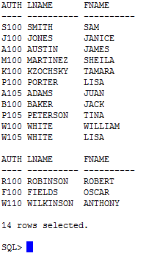

**Practice Problem 2:** Use the SELECT statement to retrieve several columns from one of the tables in the database.

**Helpful Hints:**

|  |  |
| --- | --- |
| **Key Words to Use:** | SELECT, FROM |
| **Tables to Use:** | Any table from the JustLee Books database |
| **Columns to Select:** | Any 2 or more columns |
| **Conditions to Specify:** | None |
| **Suggestions:** | List the names of 2 or more columns in the SELECT statement, or use Select * to retrieve all the columns. |

**Expected Output:**

**Note:** records in the output might be in a different order

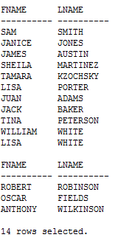

**Practice Problem 3:** Use the SELECT statement to retrieve one column from one of the tables in the database. Use an alias for that column.

**Helpful Hints:**

|  |  |
| --- | --- |
| **Key Words to Use:** | SELECT, FROM |
| **Tables to Use:** | Any table from the JustLee Books database |
| **Columns to Select:** | Any 1 column |
| **Conditions to Specify:** | Use an alias name to display the column |
| **Suggestions:** |  |

**Expected Output:**

**Note:** records in the output might be in a different order

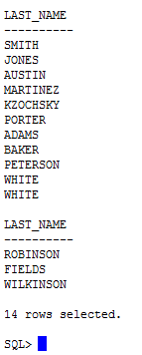

**Practice Problem 4:** Use the SELECT statement to retrieve several columns from one of the tables in the database. For one of the columns, use an alias that contains blank space(s).

**Helpful Hints:**

|  |  |
| --- | --- |
| **Key Words to Use:** | SELECT, FROM |
| **Tables to Use:** | Any table from the JustLee Books database |
| **Columns to Select:** | Any 2 or more columns |
| **Conditions to Specify:** | Use an alias for a column that contains blank spaces |
| **Suggestions:** |  |

**Expected Output:**

**Note:** records in the output might be in a different order

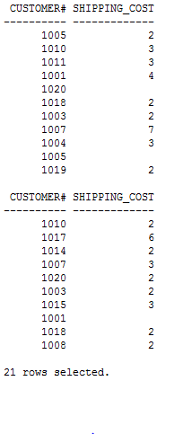

**Practice Problem 5:** Use the SELECT statement to retrieve several columns from one of the tables in the database. Perform a basic arithmetic operation on columns.

**Helpful Hints:**

|  |  |
| --- | --- |
| **Key Words to Use:** | SELECT, FROM |
| **Tables to Use:** | Any table from the JustLee Books database |
| **Columns to Select:** | Any 3 or more columns(include at least 2 columns on which arithmetic operations like +, -, *, / can be performed) |
| **Conditions to Specify:** | None |
| **Suggestions:** | Use an alias name to display the columns on which the arithmetic operation is performed. However, this is not mandatory. |

**Expected Output:**

**Note:** records in the output might be in a different order

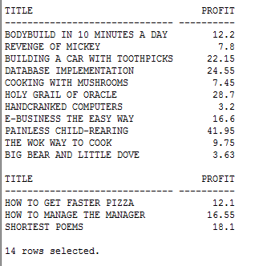

**Practice Problem 6:** Use the SELECT statement to retrieve one column from one of the tables in the database. Use DISTINCT or UNIQUE to suppress duplicates.

**Helpful Hints:**

|  |  |
| --- | --- |
| **Key Words to Use:** | SELECT, FROM, DISTINCT (or) UNIQUE |
| **Tables to Use:** | Any table from the JustLee Books database |
| **Columns to Select:** | Any 1 column |
| **Conditions to Specify:** | None |
| **Suggestions:** |  |

**Expected Output:**

**Note:** records in the output might be in a different order

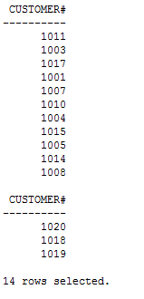

**Practice Problem 7:** Use the SELECT statement to retrieve two character columns from one of the tables in the database. Use concatenation to combine data from the two columns. Make sure to include a space between the two values and use an alias.

**Helpful Hints:**

|  |  |
| --- | --- |
| **Key Words to Use:** | SELECT, FROM |
| **Tables to Use:** | Any table from the JustLee Books database |
| **Columns to Select:** | Any 2 columns of data type ‘char’ |
| **Conditions to Specify:** | Include a space between the two values and use an alias |
| **Suggestions:** |  |

**Expected Output:**

**Note:** records in the output might be in a different order

